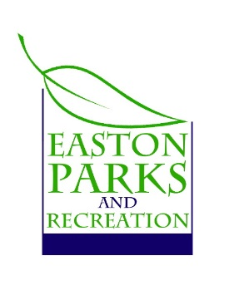
Easton Park & Recreation

PHOTOGRAPHY CONSENT FORM

Dear Parents/Guardians,

At Park & Recreation/Extended Day we use our website, brochure and Facebook page to keep parents of children attending our programs/Extended Day/camps updated online.

As the parent of a child/children at ________________________, I agree to the following: I understand that my child(ren) whose name(s) are listed below may be photographed at programs/camps/Extended Day, field trips, or activities. I understand that these photographs may be used either in print or on the Internet. At no point will names be published.

I do give permission for Easton Park & Recreation to use my childs(rens) photo’s.

I do not give permission for Easton Park & Recreation to use my childs(rens) photo’s.

Parent/Guardian Name |  | Relationship to Child
Child 1 Name

Child 2 Name

Child 3 Name

Address

City | State | Zip
I give permission for my child(ren) to be photographed, or their images recorded for print or electronic use. I understand that it is my responsibility to update this form in the event that I no longer wish to authorize the above uses. I agree that this form will remain in effect during the term of my child’s enrollment. I understand that there will be no payment for me or my child’s participation.
Parent/Guardian Signature |  | Date

